Who was President Reagan?

Ronald Wilson Reagan was born on February 6, 1911, in Tampico, Illinois, in a little apartment on the main street of town. His father was named John Edward, his mother, Nelle, and his older brother, Neil. Ronald Reagan was given the nickname “Dutch” by his father; because, as a baby he looked like a “fat little Dutchman.”

Despite the fact that his father was an alcoholic, Reagan deeply loved and admired him. John (or “Jack,” as he was called) was a man who believed passionately in individual rights and the working man. Reagan said, “Among the things he passed on to me were the belief that all men and women, regardless of their color or religion, are created equal and that individuals determine their own destiny; that is, it’s largely their own ambition and hard work that determines their fate in life (www.amazon.com/An-American Life-Ronald-Reagan/ dp/144234178). In other words, if people take the initiative and are willing to work hard, they can affect their lives in a positive way.

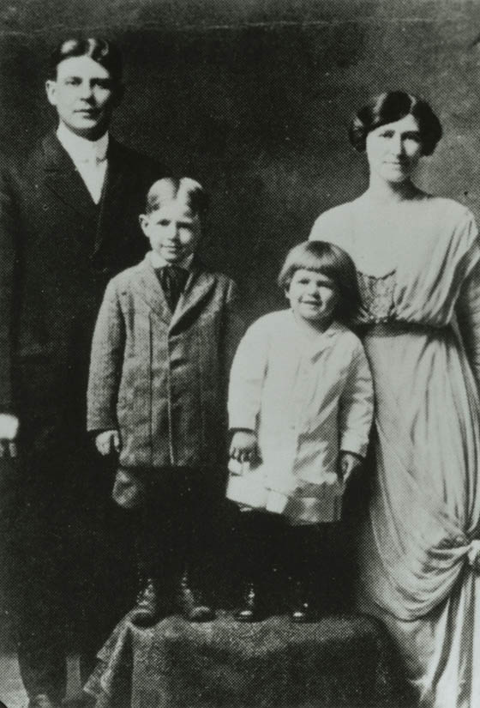

His mother was a devout Christian, seldom missing a Sunday in church. Reagan recalled, “She always expected to find the best in people and often did, even among the prisoners at our local jail to whom she frequently brought hot meals. … From my mother, I learned the value of prayer, how to have dreams, and believe I could make them come true” (ibid).

In 1920, the Reagans moved to Dixon, Illinois and rented the home in the picture below for $15 a month. “Dutch” was almost 10 years old at the time.
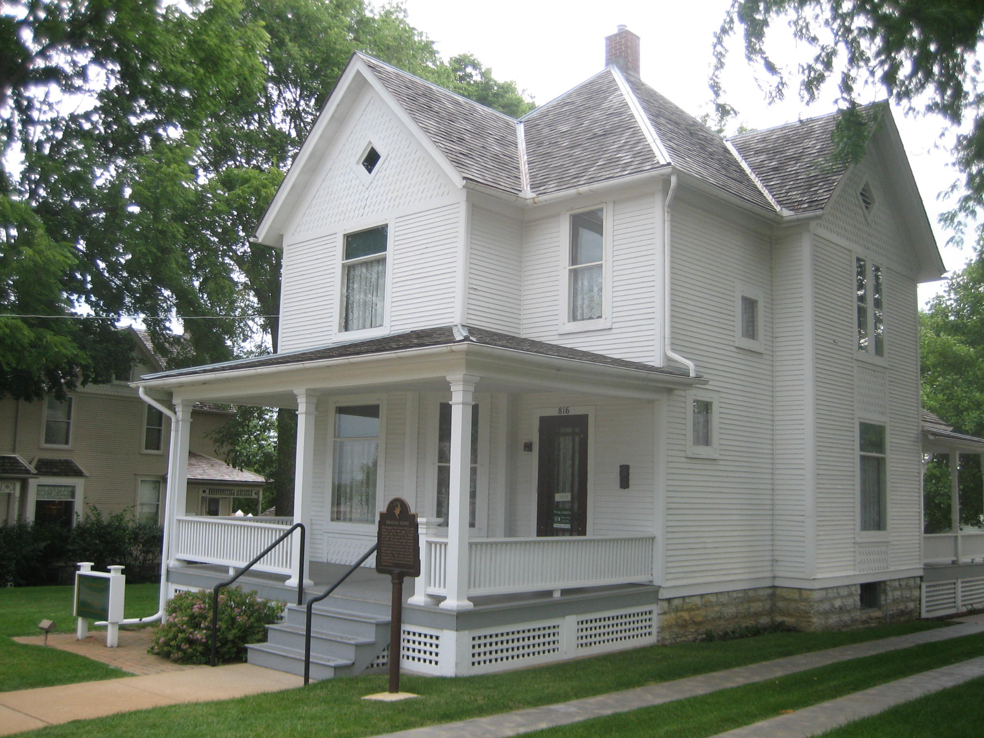
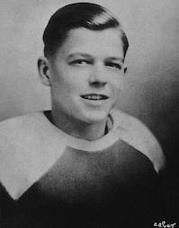

He attended Dixon High School and became involved in school plays, yearbook, baseball, basketball, track, and football. He was also elected student body president. For seven different summers, he worked as a lifeguard at Lowell Park and is credited with saving 77 lives.

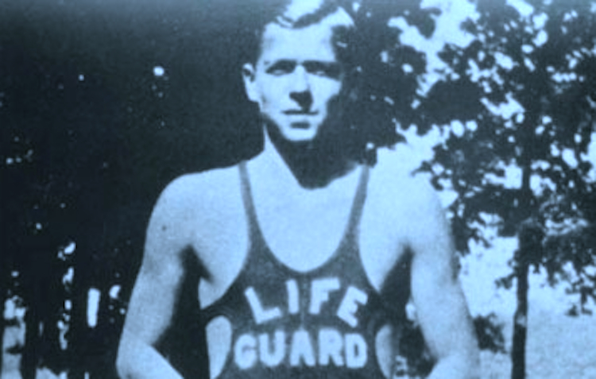

Reagan graduated from Eureka College with a Bachelor of Arts degree in Economics and Sociology. At Eureka College, he was again involved in extracurricular activities including football, swim team, and drama. He was the yearbook editor, a school newspaper reporter, and a member of the student council. He made his first speech at Eureka, later commenting it was “as exciting a speech as any he ever gave, and for the first time in his life, he felt the words reach out and grab an audience” (http://www.pjstar.com/news/x1293265752/Ronald-Reagan-timeline-at-Eureka-College).

The following is an account, in Reagan’s own words, of a pivotal moment in his young life. He was living in Dixon, having graduated from college, at a time in America’s history called, “The Great Depression. (According to Webster’s Dictionary, “The Great Depression” was the “longest and most severe economic depression ever experienced by the Western world.” It
started with the Stock Market crash of 1929 and was marked by widespread unemployment
and poverty.)

“I've often wondered at how lives are shaped by what seem like small and
inconsequential events, how an apparently random turn in the road can lead
you a long way from where you intended to go -- and a long way from
wherever you expected to go. For me, the first of these turns occurred in the
summer of 1932, in the abyss of the Depression.

“They were cheerless, desperate days. I don't think anyone who did not live
through the Depression can ever understand how difficult it was. In the
words of Franklin D. Roosevelt, ‘the country was dying by inches.’ There
were millions of people out of work. The unemployment rate across the
country was over twenty-six percent. Every day the radio crackled with
announcements warning people not to leave home in search of work
because, the announcer said, there were no jobs to be found anywhere.
There were no jobs, and for many, it seemed as if there was no hope.
“In Dixon, the town in northwestern Illinois where I lived, many families had
lost their land to crushing debt; the cement plant that provided many of the
jobs had closed; on downtown streets there were perpetual clusters of men
huddled outside boarded-up shops.
“I'd been lucky. In the summer of 1932, I'd been able to work a seventh
summer as a lifeguard at nearby Lowell Park and had saved enough money to
finance a job-hunting trip. I had a new college diploma that summer and a lot
of dreams.
“ … I hitchhiked to Chicago after the swimming season ended with visions of
getting a job as a radio announcer. But all I got was rejection: No one
wanted an inexperienced kid, especially during the Depression. And so I had
hitchhiked back to Dixon in a storm, my dreams all but smothered by this
introduction to reality.
“If there was ever a time in my life when my spirits hit bottom, it was
probably the day I thumbed my way back to Dixon in the rain, tired,
defeated, and broke.
“But when I got home, my dad told me he had some good news: The
Montgomery Ward Company had just decided to open a store in Dixon and
was looking for someone who had been prominent in local high school sports
to manage the sporting goods department. The job paid $12.50 a week.
“Suddenly, I had a new dream -- not one as seductive as my real dream, but
one that seemed to be more grounded in reality, and for a time late that
summer, nothing in the world was as important to me as managing the
sporting goods department of the new Montgomery Ward store. I loved
sports; I'd lettered in football in high school and college and loved just about
every other sport there was. The job offered me the chance not only to help
out my family financially at a time it really needed it, but to get started on a
life career. Even during the Depression, Montgomery Ward had a reputation
as a steady employer and I knew that if I did well in the sporting goods
department, promotions would follow.
“ I told my father I'd run the best sporting goods department Montgomery
Ward had ever seen, and when I applied for the job with the manager of the
store, I told him the same thing, and then waited for his decision.
“His decision several days later was a heartbreaker. He gave the job to a
former superstar on our high school basketball team.
“I was raised to believe that God has a plan for everyone and that
seemingly random twists of fate are all a part of His plan. My mother -- a
small woman with auburn hair and a sense of optimism that ran as deep as
the cosmos -- told me that everything in life happened for a purpose. She
said all things were part of God's Plan, even the most disheartening
setbacks, and in the end, everything worked out for the best. If something
went wrong, she said, you didn't let it get you down: You stepped away from
it, stepped over it, and moved on. Later on, she added, something good will
happen and you'll find yourself thinking – ‘If I hadn't had that problem back
then, then this better thing that did happen wouldn't have happened to me.’
“After I lost the job at Montgomery Ward, I left home again in search of
work. Although I didn't know it then, I was beginning a journey that would
take me a long way from Dixon and fulfill all my dreams and then some. My
mother, as usual, was right” (www.amazon.com/An-American-Life-Ronald-
Reagan/dp/.../144234178, Chapter One).

Nelle Reagan was right; her son did finally become a radio announcer … and more! He first got a job as a sportscaster and later as a full-time staff announcer. Then, while he was reporting on spring training with the Chicago Cubs in California, he made a screen test for Warner Bros. They thought he was handsome and liked his natural charm, so they offered him a seven year contract.

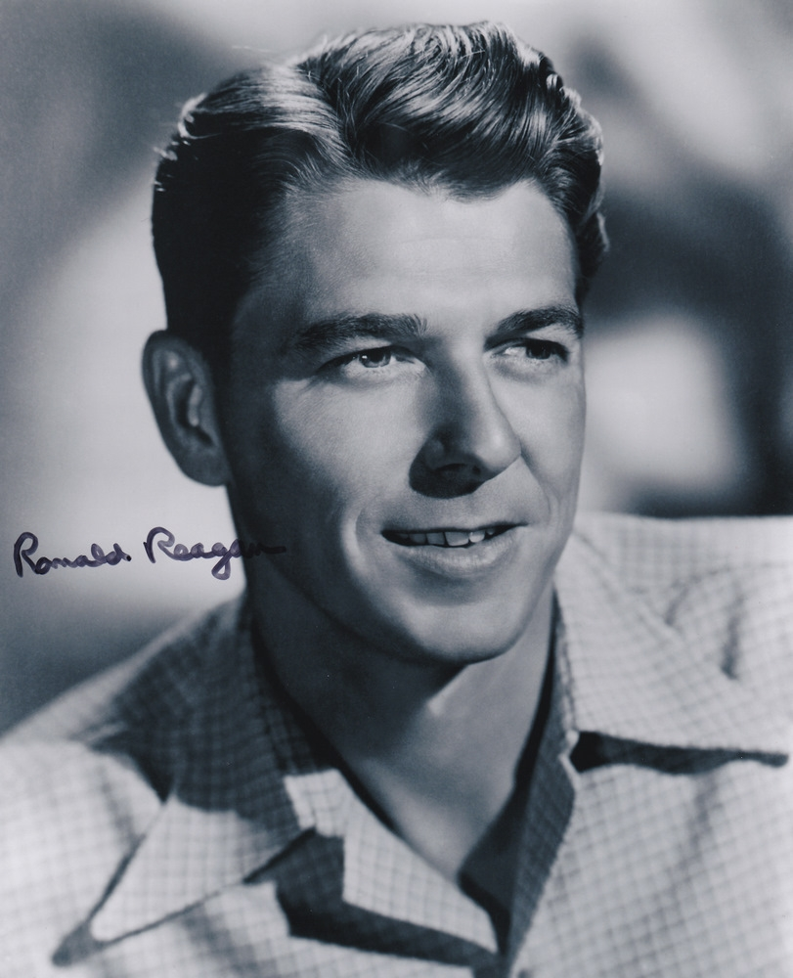

He joined the Army Reserve in 1935. Two years later, he was promoted to Second Lieutenant in the Reserve Corps of the Cavalry. In the Cavalry, he learned to ride horses, which was something he enjoyed doing all his life.

Though Europe was drawn into WWII by 1939 with Hitler’s invasion of Poland, America did not become fully engaged until the bombing of Pearl Harbor on December 7, 1941. Like other men in America, in 1942, Reagan was called to active duty. Because he had eyesight difficulties, he was unable to serve overseas. He was assigned to the U.S. Army Air Corp’s First Motion Picture Unit, and worked his way up to the rank of Captain. Here, he “served as Personnel Officer, Post Adjutant, and Executive Officer. By the end of the war, his units had produced some 400 training films for the Army Air Forces” (www.reagan.utexas.edu/archives/
reference/ military).‎

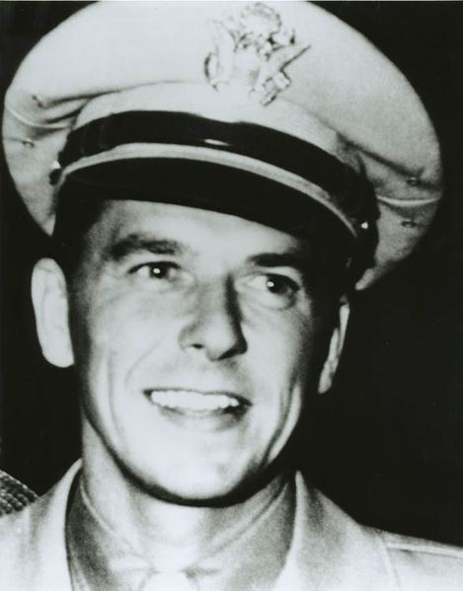

After the war, he stayed in Hollywood going on to make a total of 53 motion pictures. Having been through a divorce earlier in 1948, he met Nancy Davis while serving as president of the Screen Actors Guild (SAG). Nancy came to him for advice because she was “embroiled in an effort to remove her name from the notorious McCarthy-era Hollywood blacklist of possible Communist sympathizers” (http://www.history.com/this-day-in-history/ronald-reagan-and-nancy-davis-marry).

They fell in love and were married in 1952. Throughout President Reagan’s life, they were very devoted to each other and were married for more than 50 years.

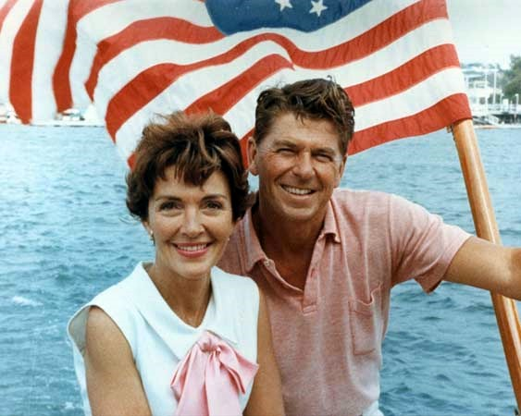

During this time, he realized his interest in politics was growing and his interest in acting waning. He was hired by General Electric to travel the country and give speeches as their celebrity spokesperson.

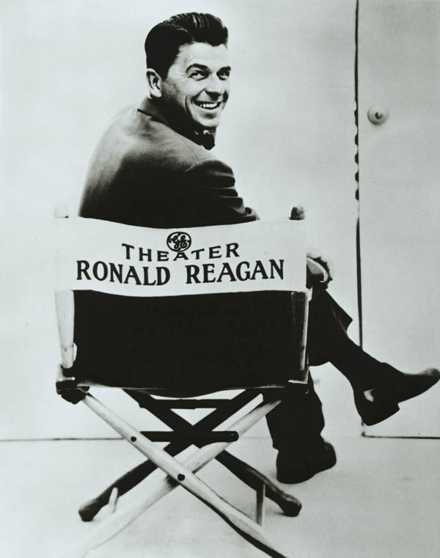

In 1960, Reagan turned his sites completely to politics and campaigned for Richard Nixon as a “Democrat for Nixon.” In 1962, he switched political parties. When he gave a televised speech for presidential candidate, Barry Goldwater, called: A Time for Choosing, it was so well received that it raised a record $8 million for the Goldwater campaign. People started to take notice and his political career was launched. In 1966, he was elected Governor of California, where he served for eight years, from 1967 through 1975.

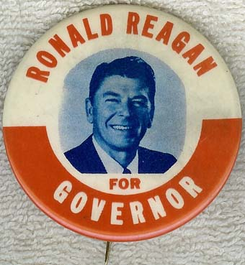

After two terms as Governor, he wanted to run for President, but did not get his party’s nomination. Not willing to give up, he ran again for the Presidency, and this time, he got the nomination. He went on to overwhelmingly win the vote of the general election and in 1981 Ronald Reagan was inaugurated as 40th President of the United States.

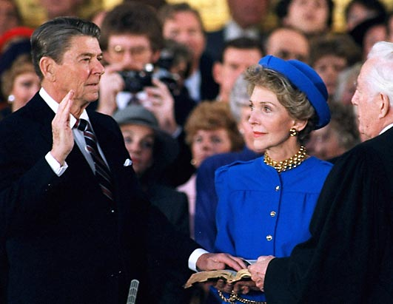

“As President, Reagan implemented sweeping new political and economic initiatives. His policies, dubbed ‘Reaganomics,’ advocated reducing tax rates to spur economic growth, controlling the money supply to reduce inflation, deregulation of the economy, and reducing government spending. [In 1981 he appointed the first woman to the Supreme Court.]

“In his first term he survived an assassination attempt, took a hard line against labor unions, and ordered military actions in Grenada. He was reelected in a landslide in 1984, proclaiming it was ‘Morning in America.’

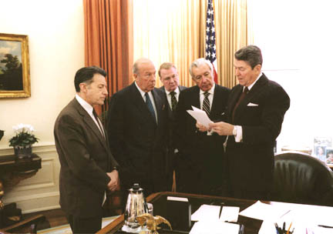

“His second term was primarily marked by foreign matters, such as the ending of the Cold War, the 1986 bombing of Libya, and the revelation of the Iran-Contra Affair” (http://reagan home.org/).

Reagan, as well as Britain’s Prime Minister, Margaret Thatcher, was clearly anti-Communist, calling Soviet Russian domination an “evil empire.” He strategically engaged the Soviets in an arms race, and at the same time openly invited a relationship of negotiation. It was this blend of genuine, personal regard, united with immovable conviction that historians identify as the key dynamic in his successful dealings with Soviet leader Mikhail Gorbachev.

On June 12, 1987, at the Brandenburg Gate separating East and West Germany, Reagan gave his famous challenge:

“We welcome change and openness; for we believe that freedom and security go
together, that the advance of human liberty can only strengthen the cause of world
peace. There is one sign the Soviets can make that would be unmistakable, that
would advance dramatically the cause of freedom and peace. General Secretary
Gorbachev, if you seek peace, if you seek prosperity for the Soviet Union and
eastern Europe, if you seek liberalization, come here to this gate. Mr. Gorbachev,
open this gate. Mr. Gorbachev, Mr. Gorbachev, tear down this wall!”

On November 9, 1989, (twenty-nine months after the speech) East Germany opened the Berlin Wall, which had been closed for nearly 30 years.[See our website for more pictures and information on this story.] As the Wall, a symbol of the Cold War, was dismantled piece by piece, so was the Communist Regime’s power over governments in Eastern Europe.

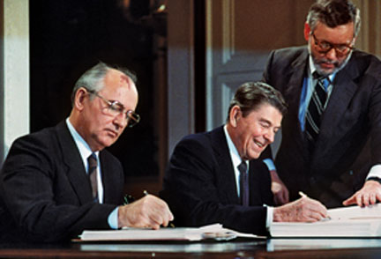

“In December of 1991, as the world watched in amazement, the Soviet Union disintegrated into fifteen separate countries. Its collapse was hailed by the west as a victory for freedom, a triumph of democracy over totalitarianism, and evidence of the superiority of capitalism over socialism” (http://www.coldwar.org/articles /90s/fall_of_the_ soviet_union.asp).

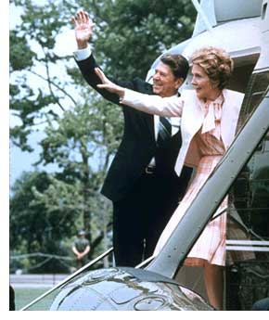

Reagan left office in 1989 after serving two full terms. He and Nancy retired to their home in Bel Air, California, but kept their ranch in the Santa Barbara area as a retreat. Rancho del Cielo had been called “the Western Whitehouse,” because Reagan had visited so often during his Presidency (even entertaining foreign dignitaries there like: Queen Elizabeth, Prime Minister Margaret Thatcher, and Mikhail Gorbechev). The picture below is of President Reagan, Queen Elizabeth, Nancy Reagan, and Prince Phillip (Queen Elizabeth’s husband) while they are at the ranch.

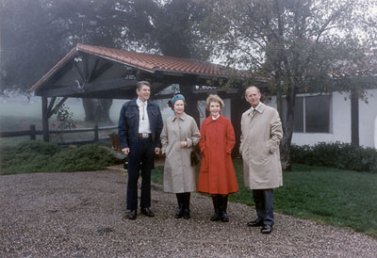

“Ronald Reagan quite literally built much of Rancho del Cielo, from the modest expansion of the adobe home itself, to the creation of the pond outside the house, where he enjoyed canoeing with Mrs. Reagan in his leisure time. [His] only genuine forms of relaxation—at least by most definitions—were his horseback rides during the day and his reading by the hearth in the evenings” (yaf.org › The Reagan Ranch).

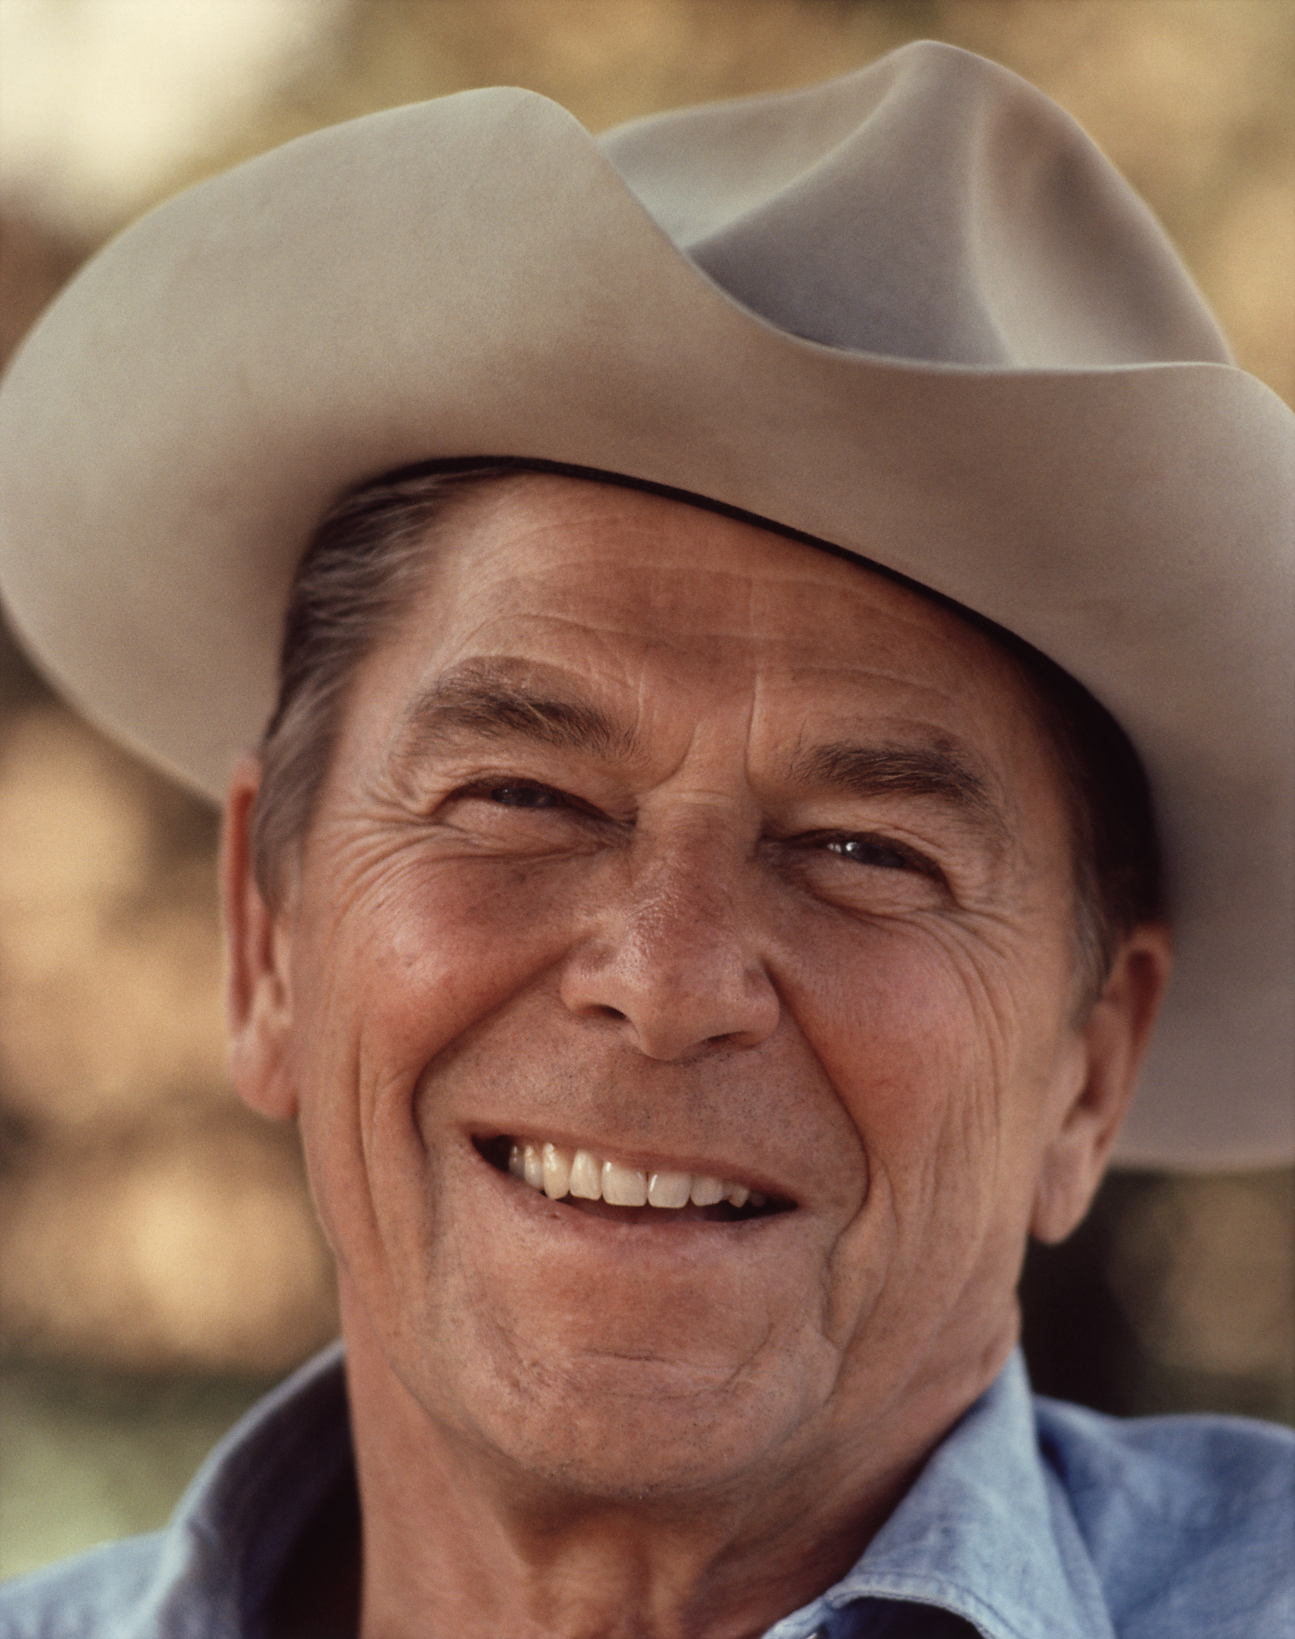

In 1994, the former president disclosed in a letter to the world that he had been diagnosed with Alzheimer's disease earlier in the year. After living with the disease for ten years, he died at the age of 93. His wife, Nancy, devotedly cared for him throughout this ordeal. He is buried at the Reagan Library in Simi Valley, California.

